Paper Preparation Guide for 2nd International and 8th National Congress on Electrical Engineering and Intelligent Systems
First Author¹, Second Author², Third Author¹
¹Department of Electrical Engineering, Na.C., Islamic Azad University, Najafabad, Iran
²Smart Microgrid Research Center, Na.C., Islamic Azad University, Najafabad, Iran

Abstract: This electronic document is a “live” template and defines the components of your paper [title, text, heads, etc.] in its style sheet. *CRITICAL: Do Not Use Symbols, Special Characters, or Math in Paper Title or Abstract. Please follow the mentioned points carefully. The abstract should not be more than 200 words. Please adjust the height of this box according to the abstract length.

Keywords: Please provide 4 to 5 keywords that are ordered alphabetically and separated by comma.

1. Introduction
This template, modified in MS Word and saved as a “Word Document” for the PC, provides authors with most of the formatting specifications needed for preparing electronic versions of their papers. All standard paper components have been specified for three reasons: (1) ease of use when formatting individual papers, (2) automatic compliance to electronic requirements that facilitate the concurrent or later production of electronic products, and (3) conformity of style throughout a conference proceeding. Margins, column widths, line spacing, and type styles are built-in. The top and bottom margins are 25 mm while the right and left margins are 20 mm. To adjust the margins, go to the Layout tab, Page Setup option. The template is a single-column paper. The required fonts are Arial and Calibri. The font size for the main body is 11. The maximum paper length is 8 pages.
2. Mathematic Equations
To insert equations, please go to the Insert tab, Equation option. For example, the droop control for inverter-interfaced distributed generations is expressed as
$$\left\{\begin{matrix}ω=ω_{0}-m×(P-P_{ref}) \\ E=E_{0}-n×(Q-Q_{ref})\end{matrix}\right.$$ | (1)
After each equation, all parameters should be defined, provided that they are not defined previously. For example, after the above equation, the authors should state that: where $ω$ and $E$ are the angular frequency and amplitude of reference voltage for inverter control system, respectively.
3. Tables
To insert tables, please go to the Insert tab and Tables section. All tables should be mentioned in the main text. The table should be presented in one page. Table 1 shows a sample table.

Table 1: Font Size of Various Sections
Section | Font Size
Main Text | 11
Abstract and Keywords | 12
Figures and Tables Caption | 10
References | 9

4. Figures
To insert figures, please go to the Insert tab and Pictures item. All figures should be mentioned in the main text. The figures should be prepared with high-quality. Fig. 1 shows a sample figure.

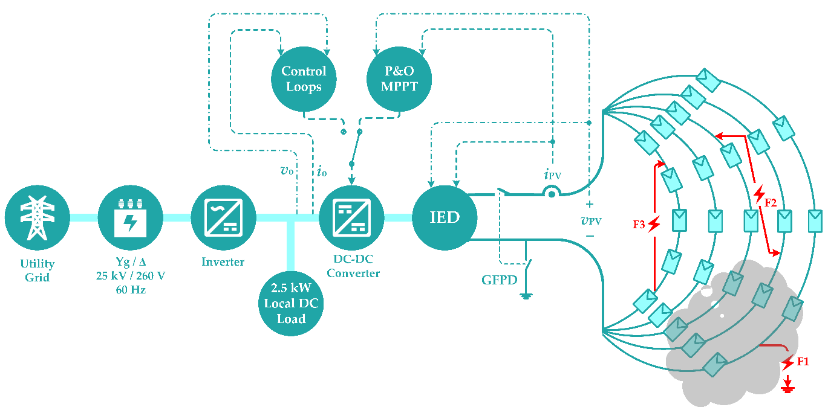
Fig. 1: Study PV system.

5. Some Points
- Don’t numbering paper pages;
- Please insert a space between a number and its unit; e.g., 400 kV; and
- Don’t insert a space between a word and parenthesis.
6. References
The references style is based on the IEEE format. All references should be in English and cited in the main text. Some examples are provided as follows.

- H. Karimi, G. Shahgholian, B. Fani, I. Sadeghkhani, M. Moazzami, "A protection strategy for inverter interfaced islanded microgrids with looped configuration", Electrical Engineering, vol. 101, no. 3, pp. 1059-1073, Sep. 2019 (doi:10.1007/s00202-019-00841-6).
- J. Faiz, M. Ebrahimi-Salari, G. Shahgholian, "Reduction of cogging force in linear permanent magnet generators", IEEE Trans. on Magnetics, vol. 40, no. 1, Jan. 2010 (doi: 10.1109/TMAG.2009.2027900).
- K. Khani, G. Shahgholian, B. Fani, M. Moazzami, M. Mahdavian, M. Janghorbani, "A comparsion of different structures in wind energy conversion systems", Proceeding of the IEEE/ECTICON, pp. 58-61, Phuket, Thailand, June 2017 (doi:10.1109/ECTICon.2017.8096172).
- H. Kumar, A. Gupta, R. K. Pachauri, Y. K. Chauhan, "PI/FL based blade pitch angle control for wind turbine used in wind energy conversion system", Proceeding of the IEEE/RDCAPE, pp. 15-20, Noida, Mar. 2015 (doi:10.1109/ RDCAPE.2015.7281362).
- M. Behnam, H. Pourghassem, "Spectral correlation power-based seizure detection using statistical multi-level dimensionality reduction and PSO-PNN optimization algorithm", IETE Journal of Research, vol. 63, no. 5, pp. 736-753, April 2017 (doi: 10.1080/03772063.2017.1308845).
- E. Hosseini, E. Aghadavoodi, G. Shahgholian, H. Mahdavi-Nasab, "Intelligent pitch angle control based on gain-scheduled recurrent ANFIS", Journal of Renewable Energy and Environment, vol. 6, no. 1, pp. 36-45, 2019.
- A. Behdan, B. Fani, E. Adib, "Reliability evaluation of power system SVC types using a markov chain", Journal of Intelligent Procedures in Electrical Technology, vol. 6, no. 2, pp. 13-22, Summer 2015 (in Persian).
- H. Bisheh, M. Moazzami, B. Fani, G. Shahgholian, "A new method for controlling microgrids protection settings with the high penetration of distributed generation", Computational Intelligence in Electrical Engineering, vol. 10, no. 4, pp. 71-90, Winter 2020 (in Persian).
- G. O. Young, "Synthetic structure of industrial plastics", In Plastics, 2th Edition, Vol. 3, J. Peters, Ed. New York: McGraw-Hill, pp.15-64, 1964.
- J. Jones, Networks, (2th Edition), May 1991, [Online] Available: http://www.atm.com

